CTODS Lab Viewer

caXchange – ScenPro, Inc.
Ekagra

Technical Architecture Guide
DOCUMENT CHANGE HISTORY
Version Number | Date | Contributor | Description
V1.0 | 2/19/2007 | M. Medirratta  C. Griffin  W. Ver Hoef | New Document
1.1 | 1/11/2008 | Michael Holck | Converted to new template and removed hub content


Updated January 23, 2008

TABLE OF CONTENTS
1 Introduction 1
1.1 Chapter Organization and Content 1
1.2 Overview of the Guide 1
1.3 Organization of the Guide 2
1.4 Intended Audience for the Guide 2
1.5 Scope of the Guide 2
1.6 Document Text Conventions 3
1.7 Related documents 4
2 Overview of the Software 5
2.1 Chapter Organization and Content 5
2.2 Software Overview 5
2.2.1 Project Background 5
2.2.2 System Overview 5
2.2.3 Features of the Lab Viewer and CCHC 6
2.3 System Requirements 6
3 Installation 7
4 Requirements 8
4.1 Chapter Organization and Content 8
4.2 Summary of Lab Viewer Requirements 8
4.3 Summary of CTODS Grid Services Requirements 8
4.4 Summary of Cancer Center Hub Client Requirements 9
5 Architecture 10
5.1 Chapter Organization and Content 10
5.2 System Architecture Overview 10
5.3 Architectural Design 11
6 Design 14
6.1 Chapter Organization and Content 14
6.2 CTODS Lab Viewer Design 14
6.2.1 Use Case 14
6.2.2 Process Flow 15
6.2.3 Sequence Diagram 16
6.3 CTODS Grid Services Design 17
6.3.1 Use Case 17
6.3.2 Process Flow 17
6.3.3 Sequence Diagrams 18
6.3.3.1 CTODS Create Study Sequence Diagram 18
6.3.3.2 CTODS Register Patient Sequence Diagram 18
6.3.3.3 CTODS CT Lab Load Sequence Diagram 19
6.4 Cancer Center Hub Client Design 20
6.4.1 Use Case 20
6.4.2 Process Flow 20
6.4.3 Data Folders 21
6.5 Technology Stack 21
7 Security and Security Management 22
7.1 Chapter Organization and Content 22
7.2 Software Authentication 22
7.3 Software Authorization 22
8 Information Model 23
8.1 Chapter Organization and Content 23
8.2 Lab Domain Model Development 23
8.3 Lab Domain Modeling Artifacts 23
8.4 Lab Domain Object Model 23
Appendix A References 26
Technical Manuals/Articles 26
caBIG Material 27
caCORE Material 27
Appendix B Glossary 28
Index 30

Introduction
The CTODS Lab Viewer is an application that allows users to view and query lab data persisted in the CTODS Lab Domain database. This application also integrates with the other applications in the CCTS suite by sending and receiving messages from them via the caXchange Hub. In addition to the Lab Viewer there is the Cancer Center Hub Client (CCHC) application that is used to transform clinical lab data from CSV or HL7v2 format to HL7v3 and submit it to the hub for persistence in Lab Viewer. While the CCHC is not strictly a component of the Lab Viewer application itself it is the easiest way for the end user to get lab data into CTODS for display in Lab Viewer so it’s design and architecture are presented here as well.
The Technical Architecture Guide provides the software architecture and high level design for the Lab Viewer and Cancer Center Hub Client applications that are a part of CCTS 1.0. This document is used as a recommendation and guideline by the development team to develop a detailed design for the system. It emphasizes the architecturally significant parts of the design model.

Chapter Organization and Content
The purpose of this chapter is to provide a high level overview of the Lab Viewer solution, its components and the overall content of this guide.
Topics in this chapter include:
- Overview of the Guide
- Organization of the Guide

- Scope of the Guide
- Document Text Conventions
- Related documents

Overview of the Guide
This guide introduces the technical and architectural aspects of the components that make up Lab Viewer 1.0 and the Cancer Center Hub Client 1.0. It provides an overview of the architecture, describes the components and their use cases, identifies the technology stack and provides some technical reference.

Organization of the Guide
This table provides a summary of the focus of each chapter.
Table 1 - Main Contents of the Lab Viewer Technical Architecture Guide
Chapter in caXchange Technical Architecture Guide | Chapter Contents
Chapter 1 | Introduction
Chapter 2 | Overview of the Software
Chapter 3 | Installation
Chapter 4 | Requirements
Chapter 5 | Architecture
Chapter 6 | Design
Chapter 7 | Security and Security Management
Chapter 8 | Information Model
Appendix A | References
Appendix B | Glossary
Index | Index

Intended Audience for the Guide
The intended audience for this document includes developers and architects interested in obtaining an overview of the architecture and high level design for the Lab Viewer and CCHC components.

Scope of the Guide
The scope of this document is limited to the requirements as identified in the 1.0 version release of the Lab Viewer and CCHC applications. For additional project and requirement-specific information, please refer to the following documents:
- Software Requirements Specification (SRS)
- Use Case Specification and Realization Document
The latest versions of these documents can be found in:
https://gforge.nci.nih.gov/plugins/scmcvs/cvsweb.php/caxchange/Deliverables/?cvsroot=caxchange

Document Text Conventions
The following table shows various typefaces to differentiate between regular text and menu commands, keyboard keys, and text that you type. This illustrates how conventions are represented in this guide.
Table 2 - Document Conventions
Convention | Description | Example
Bold & Capitalized Command  Capitalized command > Capitalized command | Indicates a Menu command  Indicates Sequential Menu commands | Admin > Refresh
text in small caps | Keyboard key that you press | Press enter
text in small caps + text in small caps | Keyboard keys that you press simultaneously | Press shift + ctrl and then release both.
Special typestyle | Used for filenames, directory names, commands, file listings, source code examples and anything that would appear in a Java program, such as methods, variables, and classes. | URL_definition ::= url_string
Boldface type | Options that you select in dialog boxes or drop-down menus. Buttons or icons that you click. | In the Open dialog box, select the file and click the Open button.
Italics | Used to reference other documents, sections, figures, and tables. | caCORE Software Development Kit 1.0 Programmer’s Guide
Italic boldface type | Text that you type | In the New Subset text box, enter Proprietary Proteins.
Note: | Highlights a concept of particular interest | Note: This concept is used throughout the installation manual.
Warning! | Highlights information of which you should be particularly aware. | Warning! Deleting an object will permanently delete it from the database.
{} | Curly brackets are used for replaceable items. | Replace {root directory} with its proper value such as c:\cabio

Related documents
For additional project information, please refer to the following documents:
- Software Requirements Specification (SRS)
- Use Case Specification and Realization Document
- Design Document
- Installation Guide
- End User’s Guide
The latest versions of these documents can be found in:
https://gforge.nci.nih.gov/plugins/scmcvs/cvsweb.php/caxchange/Deliverables/?cvsroot=caxchange

Overview of the Software

Chapter Organization and Content
Topics in this chapter include:
- Project Background
- System Overview
- Features of the caXchange Software Solution
- System Requirements

Software Overview

Project Background
The caXchange project consisted of the development of three components in support of CCTS 1.0. The first is the caXchange hub for exchanging clinical trial information between applications and systems. The second is the Lab Viewer for displaying clinical trial lab data stored in the CTODS Lab Domain Database. The third is the Cancer Center Hub Client that allows users to provide laboratory data in either CSV or HL7v2 format and upload it to CTODS.

System Overview
The components detailed in this technical architecture guide deal with the handling of clinical trial lab data in CCTS 1.0. The CCHC is a client application that aids cancer centers in getting laboratory data from their existing lab systems into the CTODS Lab Domain database. It supports CSV and HL7v2 formats to support the most common data formats that existing lab systems might be able to provide. This tool transforms this data into a standard HL7v3 CT Lab message that is sent via the hub to CTODS. The Lab Viewer is the application that allows the end user to view this laboratory data that has been uploaded. In addition, it provides that ability to send this lab data to a Clinical Trial Management System.
The key roles in the project are defined in the following table.
Table 3 - Key Roles in the caXchange Project
Role | Name | Comments
Project Sponsor | caBIG
Reviewer | caBIG Architecture Workspace | Will review and provide guidance of architecture artifacts
Reviewer | caBIG Study Conduct SIG | Will provide requirements feedback
User | NCICB | Responsible for hosting the components
Developer | Scenpro, Ekagra Software Technologies | Joint development team

Features of the Lab Viewer and CCHC
Key features of the Lab Viewer and CCHC applications include the following:
- Supports user authentication and authorization
- Supports data transformation via caAdapter and converts laboratory data into HL7v3 messages
- Provides caCORE SDK generated CTODS Lab Domain model object APIs
- Supports viewing the Lab data persisted in the CTODS Lab Domain database

System Requirements
The following table provides a very high-level summary of the requirements of the Lab Viewer and CCHC applications:
Table 4 - High Level Summary of Requirements
Requirement ID | Requirement Description
2.0 | The system must provide the ability for Cancer Centers to send patient laboratory data to the caXchange. The patient lab data will be in a caAdapter required .csv format or HL7v2. The solution should not require the Cancer Center to perform any elaborate programming.
3.0 | The system must provide the ability to receive the HL7 v3 CT Laboratory Observation Periodic Report message and persist the contained domain data in the payload into the CTODS database
4.0 | The system must be able to receive patient registration and study creation messages from C3PR and persist into the CTODS Database
6.0 | The system must provide Architectural and User documentation for the technical components developed by the caXchange technical team.

A more in-depth summary of the system requirements is presented in Chapter 4. Alternatively, a more detailed understanding of the requirements can be found in the requirements document: Software Requirements and Specification (SRS). The URL to this document is:
https://gforge.nci.nih.gov/plugins/scmcvs/cvsweb.php/caxchange/Deliverables/Updated%20Requirements%20and%20Specifications%20Document%20(Task%203.2.1).doc?cvsroot=caxchange

Installation
A separate document, the CTODS Lab Viewer Installation Guide 1.0, outlines the steps for installing and configuring the Lab Viewer application. Please refer to that document for details. The latest version of this document can be found at
https://gforge.nci.nih.gov/plugins/scmcvs/cvsweb.php/caxchange/Documentation/installation/CTODS%20Lab%20Viewer%20Installation%20Guide%201.0.doc?cvsroot=caxchange

Requirements

Chapter Organization and Content
This chapter includes:
- Summary of CTODS Lab Viewer Requirements
- Summary of CTODS Grid Services Requirements
- Summary of Cancer Center Hub Client Requirements

Summary of Lab Viewer Requirements
This section summarizes the requirements documented in the caXchange Software Requirements Specification document for the CTODS Lab Viewer.
Table 5 - Summary of Detailed Requirements
Requirement ID | Requirement Description
7.1 | Users must be provided with a graphical user interface application to query and view the patient lab data from the CTODS database via the Lab domain APIs
7.2 | Users must be able to login with a valid username and password.
7.3 | Users must be able to search for lab activities by patient identifier, study id, begin lab activity date, and end lab activity date.
7.4 | Users must be able to view the lab activity search results.
7.5 | Users must be able to select one or more lab activities from the search result and initiate a process to load them into an external CTMS system.
7.7 | The system must Integrate with Grid WebSSO such that a grid authenticated user can seamlessly navigate to and from CTODS Lab Viewer based on grid credentials
7.8 | The system must Integrate with Grid WebSSO for obtaining users authorization information to ensure that the user is allowed to perform certain operations

Summary of CTODS Grid Services Requirements
This section summarizes the requirements documented in the caXchange Software Requirements Specification document for the CTODS Grid Services.
Table 6 - Summary of Detailed Requirements
Requirement ID | Requirement Description
3.1 | The CTODS Grid Service must receive messages in the HL7v3 CT Laboratory Observation Periodic Report format
3.2 | The CTODS Grid Service must perform authentication and authorization security checks to ensure the sender is a recognized client and is authorized to send data to the CTODS Grid Service
3.4 | The CTODS Grid Service must parse the HL7 v3 CT Laboratory Observation Periodic Report messages and persist only the domain related data into the CTODS Lab Domain database
4.1 | The CTODS Grid Service must parse the C3PR Registration message and persist data pertaining to a participant within the CTODS Lab Domain database
4.2 | The CTODS Grid Service must parse the C3PR Study message and persist data pertaining to a study within the CTODS Lab Domain database

Summary of Cancer Center Hub Client Requirements
This section summarizes the requirements documented in the caXchange Software Requirements Specification document for the Cancer Center Hub Client.
Table 7 - Summary of Detailed Requirements
Requirement ID | Requirement Description
2.1 | The system should minimize the local development work to send laboratory data to the caXchange
2.2 | The CCHC must be able to retrieve laboratory data in a specified format and create a message that can be sent to the caXchange.
2.3 | The CCHC must retrieve files containing the laboratory data in a .csv format from a user defined directory
2.4 | The CCHC must poll a user defined directory repeatedly for a laboratory data file with a user specified amount of time between each polling
2.5 | The CCHC must delete, rename, or move a file after it is sent to the caXchange so it will not be resent to the caXchange.
2.6 | The CCHC must be able to send the laboratory data message to the caXchange
2.7 | The CCHC must be able to log successful and unsuccessful attempts to send messages to the caXchange
2.8 | Security will be placed on the directory that the CCHC will poll for the .csv files. The security will allow only authorized users to put .csv files in the directory.
2.9 | The CCHC must be able to transform the source data into an HL7v3 format and send to the caXchange

Architecture

Chapter Organization and Content
Topics in this chapter include:
- System Architecture Overview
- Architectural Design

System Architecture Overview
The following diagram depicts the three major components of caXchange and how they relate to each other to provide a complete solution for loading clinical trial data into the CTODS Lab Domain database.
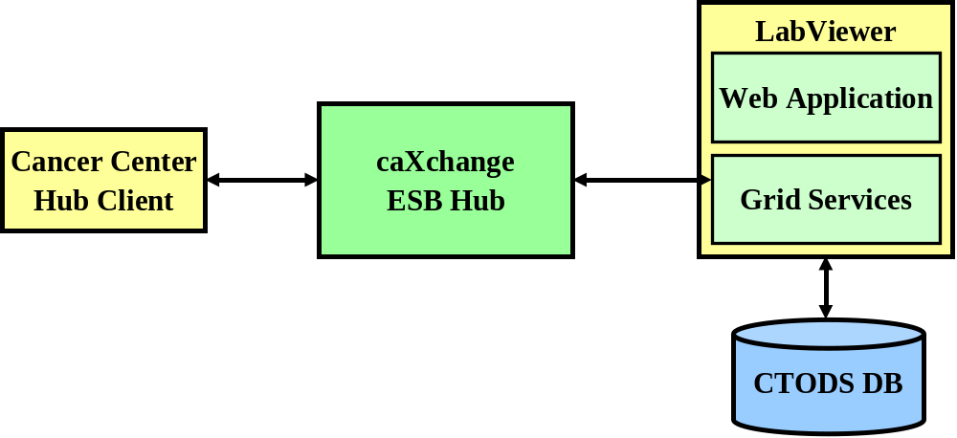
Figure 1 - caXchange High level Architecture
The Cancer Center Hub Client will be used to submit clinical trial lab data to the hub in a standard HL7v3 format. The hub will route the message to the appropriate CTODS Grid Service for processing and storage in the CTODS Lab Domain Model which will make it available for display in the CTODS Lab Viewer application.

Architectural Design
This technical architecture guide covers the architecture of 2 of the 3 major components that are a part of the caXchange effort. The first is the CTODS Lab Viewer which is used to view clinical trial laboratory data that has been stored in the CTODS Lab Domain Database. This includes the CTODS Grid Services that are used to process and store data sent to the CTODS Lab Domain Database via the hub. The second is the Cancer Center Hub Client that is used to submit clinical trial lab data to the hub for routing to the grid service that will persist it into the CTODS Lab Domain Database.
The following diagram depicts the components of the CTODS Lab Viewer:
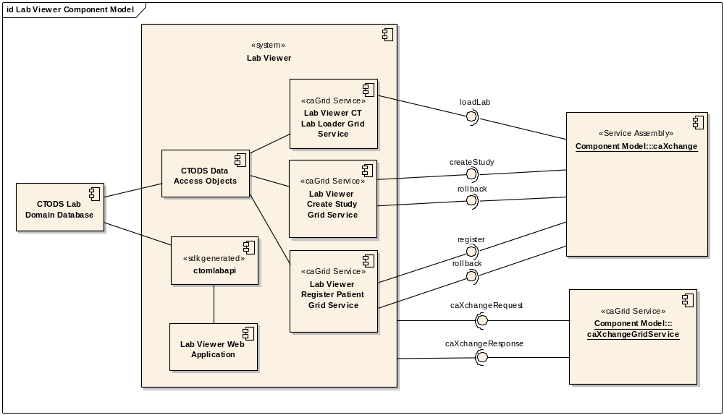
Figure 2 - CTODS Lab Viewer Component Model
The following table describes the components that make up the CTODS Lab Viewer:
Table 8 - Summary of CTODS Lab Viewer Components
Component | Description | Req’ts Addressed | Status
CTODS Lab Domain Database | The CTODS Lab Domain Database is the storage area for all clinical trial lab data. It was based off of the CTODS 1.1 model with some extension made for lab data. | 12.1 – 12.5 | The previous effort created the initial model but it required updating
CTODS Data Access Objects | The CTODS Data Access Objects are a collection of domain objects that represent the data in the model as well as some JDBC code for inserting and updating data in the CTODS Lab Domain Model | 3.4, 4.1, 4.2 | Existing code from the previous model updated for the new model
Lab Viewer CT Lab Loader Grid Service | The CT Lab Loader Grid Service is responsible for processing and persisting the clinical trial lab data that is sent from the client in HL7v3 format via te hub. | 3.1 – 3.4 | Existing code parsed the HL7v3 but was a web service. Updated to grid service.
Lab Viewer Create Study Grid Service | The Create Study Grid Service is responsible for processing the study creation message from C3PR and persisting the relevant data in the CTODS Lab Domain Database. | 4.1 | New Development
Lab Viewer Register Patient Grid Service | The Register Patient Grid Service is responsible for processing and persisting the patient registration message from C3PR. | 4.2 | New Development
Ctomlabapi | The ctomlabapi is the SDK generated APIs based on the CTODS Lab Domain model UML model | 7.3, 7.4, | Updated model rerun through SDK
Lab Viewer Web Application | The Web Application is a collection of JSPs and Struts actions that comprise the user interface and business logic of displaying the lab data to the user | 7.1 – 7.8 | Existing application updated significantly

The following diagram depicts the components of the Cancer Center Hub Client:
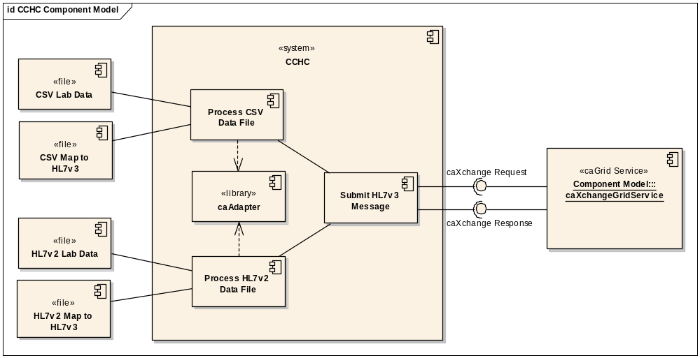
Figure 3 – Cancer Center Hub Client Component Model
The following table describes the components that make up the CCHC:
Table 9 - Summary of CCHC Components
Component | Description | Req’ts Addressed | Status
Process CSV Data File | The Process CSV Data File component reads the source CSV file and the mapping file that has been generated using caAdapter to map the CSV to HL7v3. It uses the caAdapter APIs to convert the data to HL7v3. | 2.1 – 2.5 | Mapping file had to be regenerated and caAdapter included in the CCHC
Process HL7v2 Data File | The Process HL7v2 Data File component reads the source HL7v2 file and the mapping file that has been generated using caAdapter to map the HL7v2 to HL7v3. It uses the caAdapter APIs to convert the data to HL7v3. | 2.1 – 2.5 | New Development
caAdapter | caAdapter is a product developed by NCICB for doing data transformation. The CCHC bundles the APIs within the tool for performing the transformations to HL7v3 | 2.9 | Existing product just requires some integration.
Submit HL7v3 Message | The Submit HL7v3 message component takes the completed HL7v3 message generated using caAdapter and submits it to the hub for routing to CTODS CT Lab Load Grid Service. | 2.6 – 2.7 | Modified to use the new caXchange Hub grid services

Design

Chapter Organization and Content
Topics in this chapter include:
- CTODS Lab Viewer Design
- CTODS Grid Services Design
- Cancer Center Hub Client Design
- Technology Stack

CTODS Lab Viewer Design
The CTODS Lab Viewer is the web application that allows users to view clinical trial lab data stored in the CTODS Lab Domain database.

Use Case
The primary use case for the CTODS Lab Viewer is to query laboratory data as shown in the diagram below.

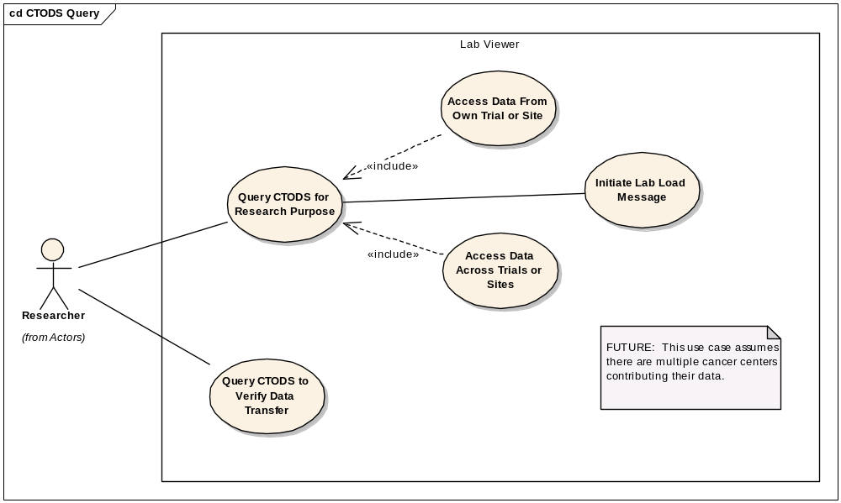
Figure 4 – CTODS Lab Viewer Query Use Case

Process Flow
The user queries for lab data using CTODS Lab Viewer in the following way:
- Logs into CTODS Lab Viewer
- Enters the search criteria including, study identifier, patient identifier, start date, and end date
- The results are displayed in a table format with checkboxes for selecting specific records
- The user can select specific labs and submit them to CTMS

Sequence Diagram
The sequence diagram below shows the basic sequence for querying lab data from the CTODS Lab Domain database.
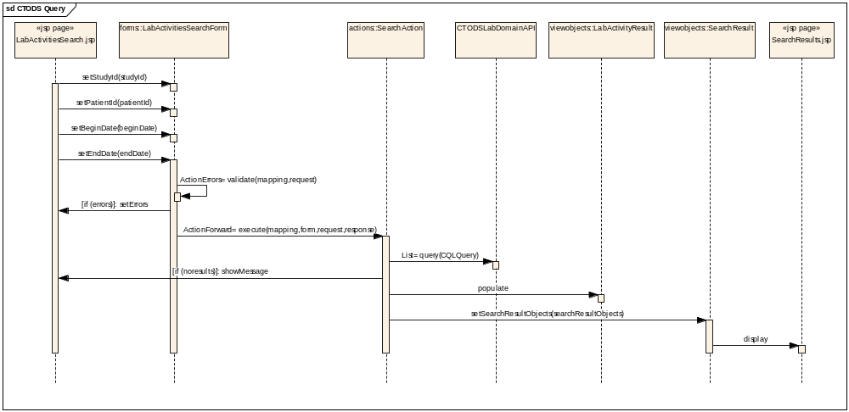
Figure 5 – CTODS Lab Viewer Query Sequence Diagram

CTODS Grid Services Design
The CTODS Grid Services are caGrid services that are used to process messages from other systems and store the data in the CTODS Lab Domain database.

Use Case
The following diagram shows the use case for all of the CTODS Grid Services.
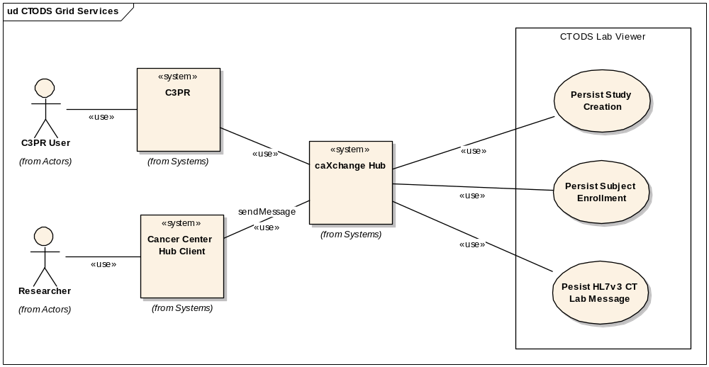
Figure 6 - CTODS Grid Services Use Case

Process Flow
The basic process flow of all the CTODS Grid Services is similar. The process is as follows:
- Receive Message from hub
- Validate the message is correct
- Check to verify that we have not already received this message
- Save the data in CTODS Lab Domain database with timestamp

Sequence Diagrams
While the basic process flow for the grid services is similar the specific implementations are slightly different. Below we show the sequence diagrams for each of the individual grid services.

CTODS Create Study Sequence Diagram
The following diagram shows the sequence for the Create Study Grid Service which processes the study message that comes from C3PR via the hub. This also shows the condition where if another system is unable to process the study message then a rollback is issued from the hub to ensure that all systems are consistent.
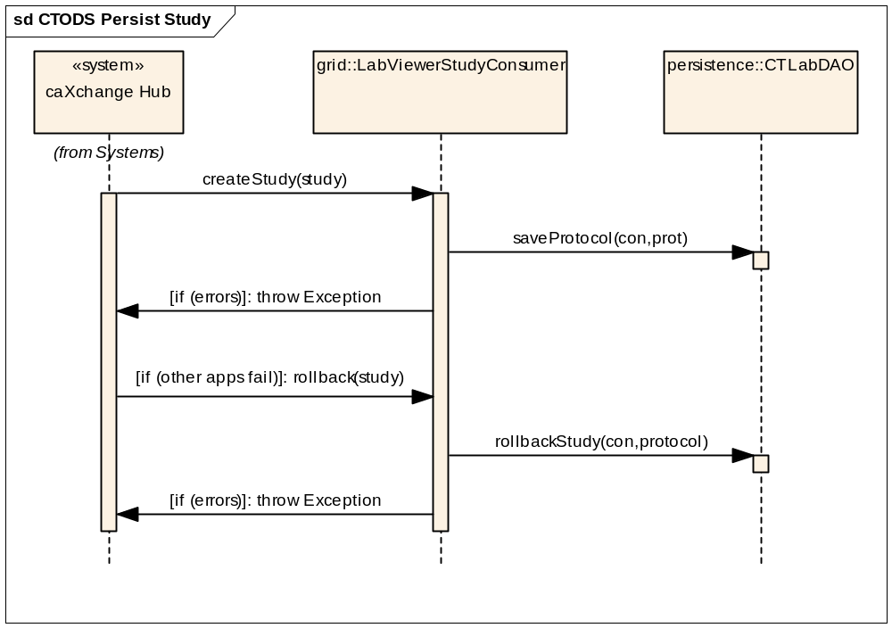
Figure 7 - CTODS Create Study Grid Service Sequence Diagram

CTODS Register Patient Sequence Diagram
The following diagram shows the sequence for the Register Patient Grid Service which processes the patient registration message that comes from C3PR via the hub. This also shows the condition where if another system is unable to process the registration message then a rollback is issued from the hub to ensure that all systems are consistent.
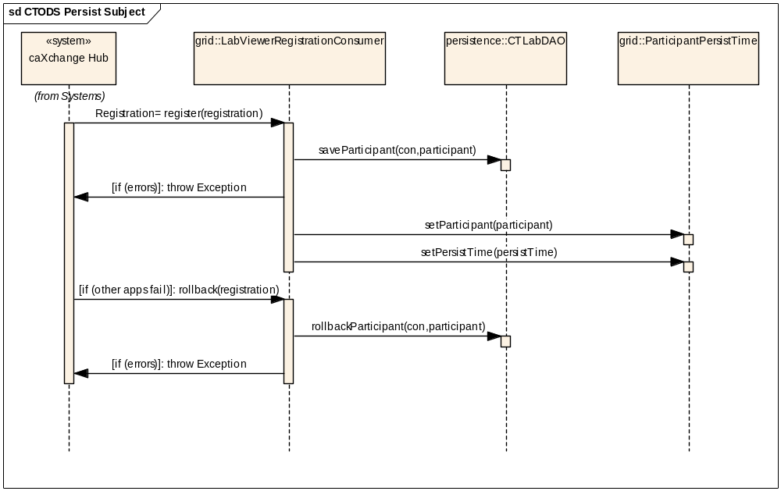
Figure 8 - CTODS Patient Registration Grid Service Sequence Diagram

CTODS CT Lab Load Sequence Diagram
The following diagram shows the sequence for the CT Lab Load Grid Service which processes the HL7v3 Lab message that comes from the CCHC via the hub.
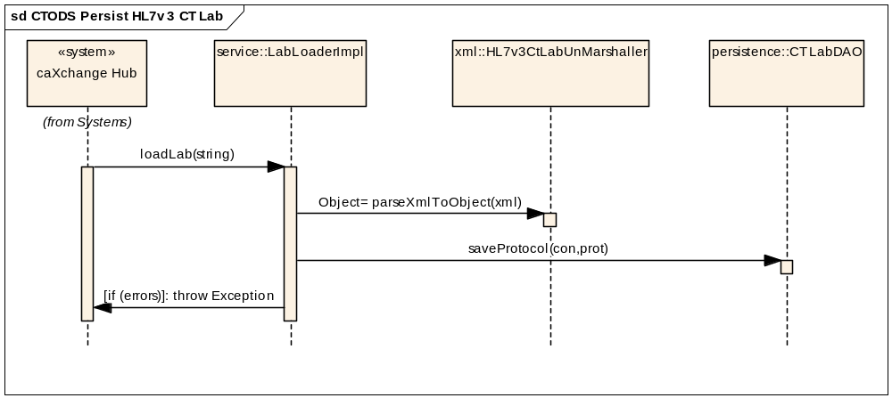
Figure 9 - CTODS CT Lab Load Grid Service Sequence Diagram

Cancer Center Hub Client Design
The Cancer Center Hub Client is the application that is used to process, transform, and submit clinical trial lab data to the caXchange hub for routing and storage in the CTODS Lab Domain database.

Use Case
The following diagram shows the use case for the Cancer Center Hub Client.
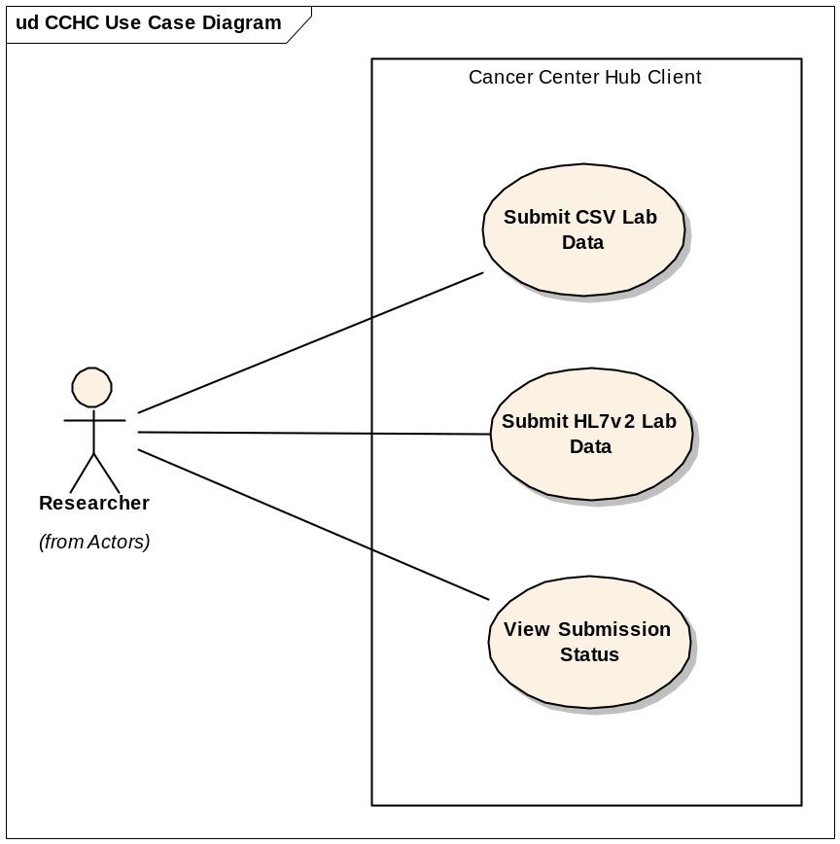
Figure 10 – Cancer Center Hub Client Use Case

Process Flow
The process flow for the Cancer Center Hub Client is as follows:
- Generate Lab Data in either CSV or HL7v2 format
- Move it to the appropriate directory to be processed
- Verify that the data was processed and submitted successfully to the hub

Data Folders
The following data folders will be created on the machine on which the Cancer Center Hub Client will be deployed and running. A description of how each one of the directories is used is provided below:
- Raw Files Folder: A folder in which data files will be placed in order to be sent to the caXchange hub. This directory is polled periodically by the client application. Once files are discovered by the polling process, the Preprocessor is invoked. The Preprocessor converts raw .csv files to a caAdapter friendly format. If the Preprocessor succeeds, the files are moved to the “In Process” folder. If the Preprocessor reports a failure, the files are moved to “Error” folder.
- In Process Folder: The CCHC application immediately attempts to transform and then send files it moves into this directory to the hub. If the send is successful, these files are moved to the “Processed” Directory. If the send is unsuccessful, the files are moved to the “Error” directory.
- Processed Folder: The client application will move all files that were successfully sent to the caXchange hub to this directory. This directory should be periodically backed up and purged.
- Error Folder: This client application will move files that were not successfully sent to the caXchange hub to this directory.
Security will be placed on all four directories to ensure only authorized personnel and processes are able to write to the directories.

Technology Stack
The following technologies are used in the CTODS Lab Viewer, Grid Services, and Cancer Center Hub Client solution or in the development of the solution:
- JDK 1.5.0
- Tomcat 5.0.28
- caAdapter 4.0
- Oracle 10g
- caGrid 1.1
- Enterprise Architect 6.1+

Security and Security Management

Chapter Organization and Content
Topics covered in this chapter include:
- Software Authentication
- Software Authorization

Software Authentication
The CTODS Lab Viewer can be configured to authenticate the users in two different ways. The first is using the Common Security Module (CSM) for performing authentication. When the Lab Viewer is installed it creates the necessary CSM schema in the database with a single valid Lab Viewer user. It also creates a valid administrator user that can use the User Provisioning Tool (UPT) that is a part of CSM to create additional users for the application. When Lab Viewer is configured to use CSM the users will be provided with a Lab Viewer specific login screen that will challenge them for their credentials and the authentication will be checked against the CSM tables in the CTODS Lab Domain database schema. The second configuration is using the caGrid WebSSO (single sign on) configuration. This configuration will redirect users who attempt to access Lab Viewer to the WebSSO login page and will put the necessary WebSSO credentials in the session and bring the user back to the Lab Viewer application. If they are configured with WebSSO then the credentials will also allow them to access other applications that are a part of the CCTS suite without re-authenticating.

Software Authorization
Regardless of which authentication method you configure CTODS Lab Viewer to use it will still use the CSM authorization. If you are using WebSSO you will need to ensure that the same user exists in the CSM schema. The password will be ignored since it is not used for authentication however, the user id must be found so that the code can verify the user is allowed to access that application. The authentication is also managed using the UPT application that is a part of CSM. For more details on how to use UPT to configure roles and users please see the CSM documentation in GForge at
https://gforge.nci.nih.gov/docman/?group_id=12

Information Model

Chapter Organization and Content
Topics covered in this chapter include:
- Lab Domain Model Development
- Lab Domain Modeling Artifacts
- Lab Domain Object Model
- CTODS Lab Domain Database Model

Lab Domain Model Development
The original Lab Domain Model was created in conjunction with the Lab Information Special Interest Group (SIG) of the CTMS Workspace. Analysts met with the SIG over the course of several months to identify and refine data elements, associations, and definitions. The starting point was a list of data elements provided by CDISC. These elements were included in the object model built in Enterprise Architect (EA). The APIs built on the CTODS Lab Domain database to retrieve lab data from CTODS are based on this object model.

Lab Domain Modeling Artifacts
The final CTODS Lab Domain model including the database model and the object model used to generate the caCORE SDK API’s were fully documented in EA. They can be found in the caXchange GForge project at the following URL.
https://gforge.nci.nih.gov/plugins/scmcvs/cvsweb.php/caxchange/Deliverables/Updated%20UML%20Static%20Class%20Diagram%20Model%20(Task%203.3.1).eap?cvsroot=caxchange

Lab Domain Object Model
The following diagram (split into two halves for easy printing) depicts the Lab Domain object model. For more information on the object mode, see the EA file referenced in the URL above.

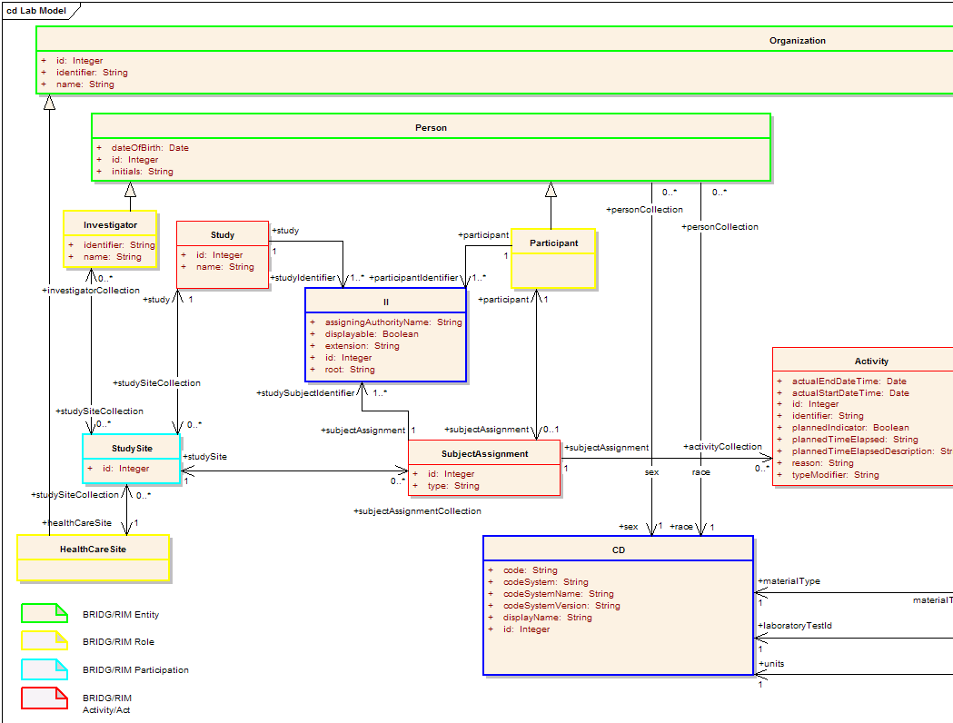
Figure 11 – CTODS Lab Domain Object Model - Left Half
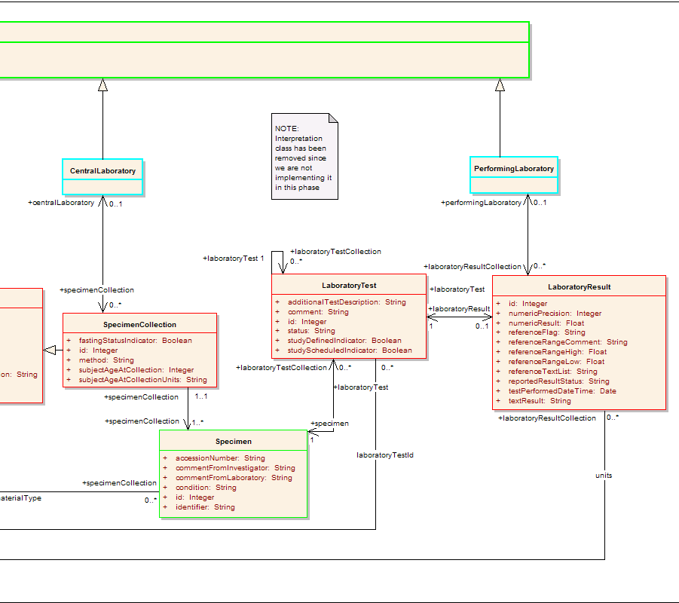
Figure 12 – CTODS Lab Domain Object Model - Right Half
Appendix A References

Technical Manuals/Articles
- National Cancer Institute. “caCORE SDK 3.2 Programmers Guide”,
http://ncicb.nci.nih.gov/infrastructure/cacoresdk
- Java Bean Specification:
http://java.sun.com/products/javabeans/docs/spec.html
- Foundations of Object-Relational Mapping:
http://www.chimu.com/publications/objectRelational/
- Object-Relational Mapping articles and products:
http://www.service-architecture.com/object-relational-mapping/
- Hibernate Reference Documentation:
http://www.hibernate.org/hib_docs/reference/en/html/
- Basic O/R Mapping:
http://www.hibernate.org/hib_docs/reference/en/html/mapping.html
- Java Programming:
http://java.sun.com/learning/new2java/index.html
- Javadoc tool:
http://java.sun.com/j2se/javadoc/
- Junit:
http://junit.sourceforge.net/
- Extensible Markup Language:
http://www.w3.org/TR/REC-xml/
- XML Metadata Interchange:
http://www.omg.org/technology/documents/formal/xmi.htm

caBIG Material
- caBIG:
http://cabig.nci.nih.gov/
- caBIG Compatibility Guidelines:
http://cabig.nci.nih.gov/guidelines_documentation

caCORE Material
- caCORE:
http://ncicb.nci.nih.gov/core
- caBIO:
http://ncicb.nci.nih.gov/core/caBIO
- caDSR:
http://ncicb.nci.nih.gov/core/caDSR
- EVS:
http://ncicb.nci.nih.gov/core/EVS
- CSM:
http://ncicb.nci.nih.gov/core/CSM
Appendix B Glossary
Term | Definition
API | Application Programming Interface
caBIG | cancer Biomedical Informatics Grid
caBIO | Cancer Bioinformatics Infrastructure Objects
caCORE | cancer Common Ontologic Representation Environment
cardinality | Cardinality describes the minimum and maximum number of associated objects within a set
CDISC | Clinical Data Interchange Standards Consortium
CSM | Common Security Module
CTMS | Clinical Trial Management Systems
CVS | Concurrent Versions System
DAO | Data Access Objects
DAS | Distributed Annotation System
EA | Enterprise Architect
EBI | European Bioinformatics Institute
EVS | Enterprise Vocabulary Services
GULCCC | Georgetown University Lombardi Cancer Center
HIPPA | Health Insurance Portability and Accountability Act
HTTP | Hypertext Transfer Protocol
ISO | International Organization for Standardization
JAAS | Java Authentication and Authorization Service
JAR | Java Archive
Javadoc | Tool for generating API documentation in HTML format from doc comments in source code (http://java.sun.com/j2se/javadoc/)
JBI | Java Business Integration
JDBC | Java Database Connectivity
JET | Java Emitter Templates
JMI | Java Metadata Interface
JSP | JavaServer Pages
JUnit | A simple framework to write repeatable tests (http://junit.sourceforge.net/)
LDAP | Lightweight Directory Access Protocol
LLT | Log Locator Tool
LOINC | Logical Observation Identifier Names and Codes
MedDRA | Medical Dictionary for Regulatory Activities
metadata | Definitional data that provides information about or documentation of other data.
Multiplicity | Multiplicity of an association end indicates the number of objects of the class on that end may be associated with a single object of the class on the other end
NCI | National Cancer Institute
NCICB | National Cancer Institute Center for Bioinformatics
OMG | Object Management Group
ORM | Object Relational Mapping
RDBMS | Relational Database Management System
SDK | Software Development Kit
Semantic connector | A development kit to link model elements to NCICB EVS concepts.
SIG | Special Interest Group
SQL | Structured Query Language
UI | User Interface
UID | User Identification
UML | Unified Modeling Language
UMLS | Unified Medical Language System
UPT | User Provisioning Tool
URL | Uniform Resource Locators
WAR | Web Application Archive
WSDL | Web Services Description Language
XMI | XML Metadata Interchange (http://www.omg.org/technology/documents/formal/xmi.htm) - The main purpose of XMI is to enable easy interchange of metadata between modeling tools (based on the OMG-UML) and metadata repositories (OMG-MOF) in distributed heterogeneous environments
XML | Extensible Markup Language (http://www.w3.org/TR/REC-xml/) - XML is a subset of Standard Generalized Markup Language (SGML). Its goal is to enable generic SGML to be served, received, and processed on the Web in the way that is now possible with HTML. XML has been designed for ease of implementation and for interoperability with both SGML and HTML

Index

APIs, 6
Architecture, 10, 11
C3PR, 6
caAdapter, 6
Client, 9
component, 1, 2, 5, 6, 10, 11, 12, 13
CTODS, 1, 5, 6, 7, 8, 10, 11, 12, 13, 14, 15, 16, 17, 18, 19, 20, 21, 22, 23, 24, 25
Database Model, 23
Features, 6
Folders, 21
Grid, 8, 9, 11, 12, 13, 14, 17, 18, 19, 21, 22, 28
HL7, 1, 5, 6, 8, 9, 11, 12, 13, 19, 20
Hub, 1, 5, 8, 9, 11, 12, 13, 14, 17, 18, 19, 20, 21
Installation, 4, 7
Object Model, 23, 24, 25
Persistence, 1
Process Flow, 15, 17, 18, 20
Requirements, 2, 4, 5, 6, 8, 9
Security, 8, 9, 21, 22, 28
Sequence Diagram, 16, 18, 19
Use Case, 1, 2, 4, 14, 15, 17, 20
Web Service, 12, 29
WSDL, 29

